How Community-led health supports your work in tackling health inequalities.
Public Health Scotland & CHEX Learning Event
31st January 2024
Public Health Scotland and CHEX have an established partnership working towards a shared ambition to improve Scotland’s health and wellbeing, reduce health inequalities and create a Scotland where everybody thrives. This event is one of a variety of ways the two organisations work together to enable collaboration across sectors and build capacity to work with communities. This includes supporting the wider public health workforce to develop knowledge, skills, and confidence in community-led approaches.
Aims for the Day
- Introduce community-led health and explore how the social model of health supports Scotland’s ambitions to reduce health inequalities.
- Explore the community development value base and principles that underpin this approach.
- Help participants think about the opportunities to deliver this approach in their work.
- Share resources and tools participants need to take the next step.
Background & Introduction
“Scotland’s health faces two challenges: low and falling life expectancy and widening health inequalities.”
Paul Johnston, CEO of Public Health Scotland, opened the in-person learning event, which was attended by over 60 participants from organisations across the public, academic, voluntary and community sectors. He opened with an overview of the stark reality of Scotland’s health, highlighting that for those living in Scotland’s poorest communities, people are not only dying 12 years before those in the least deprived areas they are spending on average 26 years in poor health – more than a third of their lives.
These trends impact on individuals, families, communities and increasingly risk the sustainability of services. Paul identified that as 40% of what shapes health are social and economic factors, the best evidence indicates that austerity and growing levels of poverty are impacting directly on Scotland’s health. This is a political issue which requires devoted political time, attention, and energy.
Paul’s presentation challenged the participants to reach out across silos, communities, and backgrounds to be part of something bigger than us and our individual organisations – a collective movement to work together to challenge and change this reality. Quoting Corretta Scott King:
“I had a growing sense that I was involved in something so much greater than myself- something of profound historical importance.”
Community-led health is a community development approach, underpinned by principles which identify that the most powerful agents of change are people and communities themselves. Susan Paxton, Director of SCDC, provided an overview of community-led health and how it enables change through collective action. Community-led health is ideally placed to underpin our collective approach across disciplines, organisations, and communities to meet our shared challenge and Paul’s call to collective action. A real-life example of community-led health in action was provided by a CHEX network member, the Ripple Project in Edinburgh.
A dedicated webpage with presentations and resources from the event is available here. Participatory Sessions
Public Health Scotland, working with CHEX, brought together a unique cross section of the wider public health workforce for this event with participants from national health and public sector agencies; universities; local NHS Boards, Health & Social Care partnerships and councils; national and local voluntary sector agencies and community led health organisations. Participants were allocated to groups to ensure a wide range of skills, experience and backgrounds were represented to:
- Share insights, experiences, and good practice.
- Explore ways to strengthen practice in working with communities.
- Network and seek collaboration opportunities.
What did participants learn?
Participatory Session 1 – Why Community-Led health?
Participants in this session were asked to reflect on their job roles, organisations and focus on health inequalities and/or community-led health in their current work.
- Most participants were aware of health inequalities and the increasing strain on public and community services and organisations, but many were shocked and unaware of the falling life expectancy.
- Fewer participants were aware of community-led health in practice.
Key priorities for future learning:
- Opportunities to hear more about community-led health, sharing good practice and continuing to raise awareness of this approach with the wider workforce.
- Ensuring that the workforce have time and space to explore the impact of rising health inequalities and the opportunities to embed aspects of community led health into practice.
Participatory Session 2 – What is community-led health in practice?
This session gave participants an opportunity to explore areas of community-led health practice and the set of core competences for practitioners, to enable them to identify areas of strength or experience and areas for future learning or development.
- Many practitioners reflected that although approaching communities with no set agenda was an important feature of successful community-led health, the workforce face challenges around participation, time, capacity and competing agendas.
- Having enough time to undertake a community-led health approach was a recurring issue for participants.
Key priorities for future learning:
- Opportunities for national and local practitioners to come together was identified and how we better enable the two to complement and support each other’s work.
- Opportunities to build trust between agencies, sectors and communities and the role that cross sectoral learning events like these play in building those relationships.
Participatory Session 3 – How can community-led health contribute to my work?
This session focussed on participants identifying key takeaway actions from the day and how tackling health inequalities and community-led health could be part of their work.
- New working relationships were established during this event, with the opportunity to explore and understand each other’s roles, priorities, and pressures. Many practitioners shared contact details and planned to meet or exchange information following this event.
- Many participants identified that additional support in their workplace, such as time or reprioritising of workload would assist them in embedding this approach.
Key Priorities for future learning
- Increased awareness of health inequalities, the social determinants of health and the importance of community-led health was identified as an ongoing priority and cannot be just a one-off event to reach the wider workforce and our communities.
- Leadership at all levels was identified as essential to collective endeavour and cross-sectoral learning opportunities would create opportunities to build leadership at community, local, regional, and national levels.
Conclusions & Recommendations
The call to collective action to build thriving communities resonated with the participants. Networks and collaborations, conversations and relationships were established as the event laid the foundations for a sense of belonging and collective ownership of the agenda with new areas of work identified to be pursued outwith the event.
PHS as a national agency is uniquely placed to build on this event to continue to raise awareness of the impact of rising health inequalities and create the building blocks for a collective endeavour to address this challenge. CHEX, with a network of over 150 community-led health organisations, is well placed to work alongside PHS in embedding community-led approaches and relationships with the community sector.
Key priorities from this learning event to be considered by the Learning into Practice Programme to support next steps:
- Relationship Building between sectors, local and national agencies and with communities. In person opportunities are the best way to build trust and effective networks.
- Creating spaces focussed on health inequalities and community-led health that enable practitioners to contextualise their own experience within the national context and improve practice.
- Reach the wider workforce to raise their awareness of the social determinants of health and their contribution to tackling health inequalities.
- Enable practitioners to share knowledge, skill, data and expertise across sectors, teams, communities, and agencies.
This collective endeavour, being involved in something bigger than individual practitioners and agencies can do alone, will require ongoing leadership, support, development, and learning opportunities as it will require a shift in how we all work. In the words of one practitioner on the day – learning to be ‘productively disruptive’.

Appendix
Organisations Represented
Aberdeen City Health & Social Care Partnership, Edinburgh Community Health Forum, Edinburgh Futures Institute, The University of Edinburgh, Fife Council, Fife Health Charity, First Step, Glasgow HSCP, Glasgow Life, Heriot-Watt University, Improvement Service, NHS Borders, NHS GGC, NHS Grampian, NHS Tayside, Perth and Kinross HSCP, Police Scotland, Public Health Scotland, SCDC / CHEX, Sniffer, Terrence Higgins Trust Scotland, The Corner.

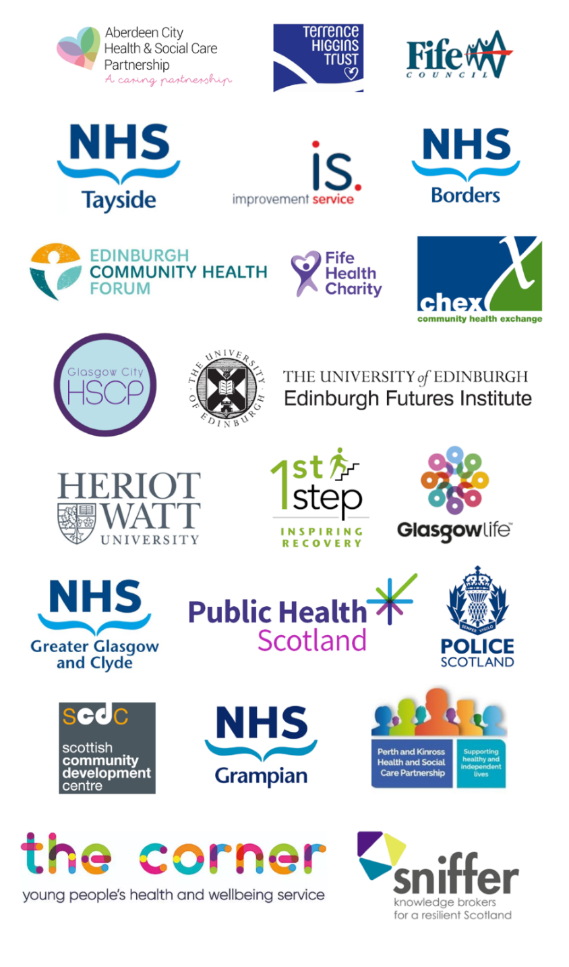

Sectors Represented

