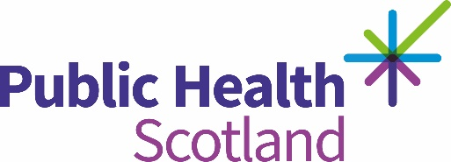
Introduction to public health learning hub
Welcome to the Introduction to public health learning hub.
Public health is about improving and protecting the health of the population.
This learning hub provides you with knowledge of public health and how it is delivered in Scotland.
Improving population health and reducing inequalities in health involves a range of sectors, who can each play a role and together have the potential to make significant differences for the people and communities of Scotland.
We would encourage you to explore the hub and the sectors, which include the role of Local Government, and the NHS, the role of Police Scotland and the voluntary and community sector and the newly added section the role of social care.
We hope you enjoy your learning on public health and would encourage you to reflect on the role you can play.
End of transcript.

