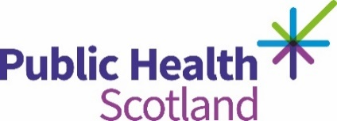

Transcript

Poverty - Our hidden story
Decided that lack of food in a lot of our areas is one of the main issues with poverty. So, we went to Crookston community group foodbank and spoke to the people there.
So why is it that you are coming to the foodbank?
It’s cause I’m short of money this week. I come every Monday. I don’t get paid until Thursday, so it helps out until Thursday.
So why is it you come to the foodbank?
Cause I got married there and from when we got married, our money got cut. So, we’ve got the wain (child) in the house and all that so if I didn’t come here, I don’t know what, probably need to go out and turn to crime, you know what I mean. Nobody else is willing to help you.

