The link between health literacy and
health inequalities

Learning journal

Learning is a process where knowledge is presented to us, then shaped through understanding, discussion and reflection
Paulo Freire

You should use this journal to reflect on your learning and reflections throughout this resource. It is recommended that you spend a reasonable amount of time on the reflective questions and activities as this will help the learning process. It can also be used for some follow up discussions with your colleagues.
On completion of this journal, you will be able to apply your learning into practice.

Please enter your name:

Effects of low health literacy
Reflecting on what you have learned so far in the module, in what ways do you think low health literacy can affect health?
You can write your reflections here:

The link between health literacy and health inequalities literacy
Previously we looked at some of the factors that can influence low health literacy.
Can you recall what the factors were?
You can write your reflections here:

The link between health literacy and health inequalities

We have learned how age, sex and hereditary factors can impact on both health literacy and health inequalities.

Thinking about the other four layers of The Social Model of Health:
- individual lifestyle factors
- social and community networks
- living and working conditions
- general socio-economic, cultural and environmental conditions.

Consider how each of these can impact on health literacy and health inequalities?
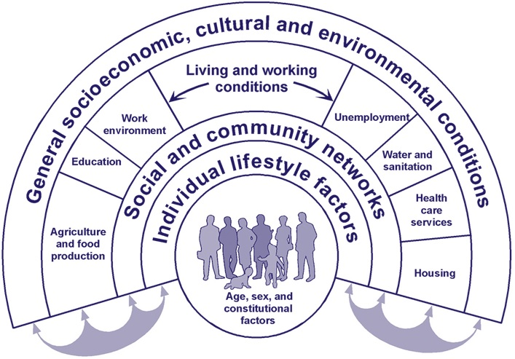
You can write your reflections below:

- Individual lifestyle factors

- Social and community networks

- Living and working conditions

- General socio-economic, cultural and environmental conditions

Identifying who is at risk literacy
Considering the above factors and any additional ones you can think of, what population groups do you think may be at higher risk of experiencing low health literacy?

To help you, think about some of the factors that influence low health literacy that we have already looked at (education, age, culture, whether English is the first language, additional communication support needs).
You can write your reflections here:

Now let’s think about some of the challenges that these high risk groups can face.
You can write your reflections below:

- What challenges do you think high risk groups may face?

- What day to day tasks might they struggle with?

- How would this affect their health?

- What would you do in your role to help?

Barriers to health literacy
Thinking about your own work, what barriers would someone with low health literacy experience when accessing your service? You may wish to consider information, staff or work environment in your response
You can write your reflections here:

- Information

- Staff

- Work environment

Health literacy call to action
Please take some time to reflect on the following questions and record the actions you will take in your action plan.

- What changes can you make to your practice?
- How can you influence colleagues and others to make changes which will positively impact on people’s health literacy?
- How can you raise awareness of health literacy and health inequalities and ensure that services are designed to meet the needs of people with low health literacy?
- What further learning needs around health literacy and health inequalities have you identified, and how will you address these?
You can write your reflections here:

The link between health literacy and health inequalities - Action Plan
How will you put what you have learned into practice? | Learning actions | How will you apply this in your role? | Who do you need to involve? | By when?
- Identify your top three learning actions you will start doing now to improve the way you communicate with people at risk of low health literacy | 1.  2.  3. | 1.  2.  3.
- What will you do to influence colleagues and others to make changes which will positively impact on people’s health literacy?
- How will you raise awareness of health literacy and health inequalities and ensure that services are designed to meet the needs of people with low health literacy?
- Any further identified learning needs for this topic?

