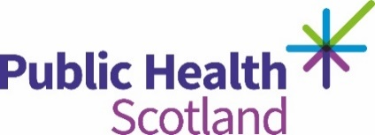

Transcript

Human Rights – PANEL Principles
The Scottish Human Rights Commission advocates that in order for organisations to take a human rights based approach we should consider The PANEL Principles. The (PANEL) principles help to make our work person focused and also ensure support is targeted at the people who need it the most.
P is for Participation
This means that you should make the necessary arrangements to enable your service users, local communities and staff to take part in policy development and service design decisions.
A is for Accountability
This means that you should hold yourself accountable and be responsible for things that are assigned to you. The Fairer Scotland duty places a responsibility on particular public bodies to consider how they can reduce inequalities caused by social economic disadvantages when making decisions. For example – when thinking about the Fairer Scotland duty you should ensure that the needs of those experiencing poverty have been considered.
N is for Non-discrimination
This means that you should ensure that everyone has the same rights regardless. Regardless of ethnicity, religion, lifestyle, gender, income and their circumstances. For example – you can ensure the work policies are inclusive enabling all staff to acknowledge a team members birthday without feeling they need to contribute financially to a gift.
E is for Empowerment
This means that you should ensure that people, groups and communities have the power and know how to claim their rights in order to make a difference. For example – you could empower service users and staff to have a voice in your service complaints process by helping to ensure that they know and understand what they are entitled to.
L is for Legality
This means all your decisions should comply with human rights legal standards. For example – when dealing with people’s information you ensure privacy and confidentiality throughout your practice.

